**Bachelor of Science in Computer Science and Engineering**



**Covid-19 Detection from X-Ray Images Using Convolutional Neural Network**

Md. Ahsan Habib

181003312

Shudipta Banik

181006112

April, 2022



**Covid-19 Detection from X-Ray Images Using Convolutional Neural Network**

**By**

Md. Ahsan Habib

181003312

Shudipta Banik

181006112

A Thesis Presented to

East Delta University

In partial fulfillment of the requirement for the degree of

**Bachelor of Science**

in

**Computer Science and Engineering**

April, 2022

The undergraduate thesis titled **Covid-19 Detection from X-ray Images Using Convolutional Neural Network** submitted by **Md. Ahsan Habib ID-181003312 and Shudipta Banik ID-181006112,** supervised by **Promila Haque** has been accepted as satisfactory in fulfillment of the requirement for the degree of Bachelor of Science (B.Sc.) in Computer Science and Engineering (CSE) to be awarded by East Delta University.

**Board of Examiners**

1. ______________________________________

Mohammed Nazim Uddin, PhD Chairman

Associate Dean & Professor

School of Science, Engineering & Technology

East Delta University (EDU)

2. ______________________________________

Md. Ishtiaque Aziz Zahed, PhD Member

Associate Professor

School of Science, Engineering & Technology

East Delta University (EDU)

3. ______________________________________

Linkon Chowdhury Member

Assistant Professor

School of Science, Engineering & Technology

East Delta University (EDU)

4. ______________________________________

Promila Haque Supervisor

Lecturer

School of Science, Engineering & Technology

East Delta University (EDU)

# **DECLARATION**

It is hereby declared that we have produced the work presented in this thesis, during the scheduled period of study. We also declare that we have not taken any material from any source except referred to wherever due that amount of plagiarism is within acceptable range.

Date:

-----------------------------------

Md. Ahsan Habib

ID:

--------------------------------------  
 Shudipta Banik

ID:

# **ACKNOWLEDGMENTS**

# 

All over the writing of this book we have gained a significant deal of brace and assistance. We want to thank Almighty first, the creator of this universe, who provided us guidance, strength and abilities to complete this research. We'd like to express our gratitude to our supervisor, Promila Haque, Ma'am, for her assistance in developing the study topics and methodology. Your insightful feedback encouraged us to improve our ideas and raise the bar on our work. We are also thankful to all of the EAST DELTA UNIVERSITY Faculty, Staffs of the Computer Science and Engineering, who have helped us a lot and encouraged us in the whole study period at EAST DELTA UNIVERSITY. Finally, we are obviously grateful to our sincere and beloved parents, siblings and friends for their love and help. We are grateful to all of them.

# **TABLE OF CONTENTS**

Contents

**DECLARATION** 4

**ACKNOWLEDGMENTS** 5

**TABLE OF CONTENTS** 6

**LIST OF FIGURES** 8

**LIST OF TABLES** 9

**ABSTRACT** 10

**Chapter 1** 11

**Introduction** 11

**1.1 Motivation and Goals** 11

**1.2 Project Scopes** 11

**1.3 Overview** 12

**Chapter 2** 13

**Literature Review** 13

**2.1 Deep Learning in Medical Image Based Diagnosis** 13

**2.2 A Brief Overview of the History** 14

**2.2.1 Current Role of AI in Radiology** 15

**2.2.2 Image/Exam Classification** 17

**2.2.3 Object or Lesion Classification** 17

**2.3 Machine Learning** 18

**2.3.1 Applications of Machine Learning** 19

**2.3.2 Types of Machine Learning Algorithm** 21

**2.3.2.1 Supervised machine learning algorithm** 21

**2.3.2.2 Unsupervised machine learning algorithms** 22

**2.3.2.3 Semi-supervised machine learning algorithms** 23

**2.3.2.4 Reinforcement machine learning algorithms** 23

**2.3.3 Deep Learning** 24

**2.3.3.1 Why Deep Learning** 24

**2.3.3.2 How Deep Learning Works** 25

**2.3.3.3 ANN-Artificial Neural Network** 26

**2.3.3.3 Working Procedure of ANN-Artificial Neural Network** 26

**2.3.4 CNN - Convolutional Neural Network** 28

**2.3.4.1 Working Procedure of CNN - Convolutional Neural Network** 28

**2.3.4.2 1D and 2D CNN** 29

**Chapter 3** 31

**Methodology** 31

**3.1 Proposed Workflow** 31

**3.2 Dataset Collection** 31

**3.3 Dataset Pre-Processing** 33

**3.3.1 Data Normalization** 34

**3.3.1.1 Normalization Techniques** 34

**3.3.1.2 Data Augmentation** 35

**3.4 Convolutional Neural Network** 35

**3.4.1 The Proposed CNN Architecture** 36

**3.4.1.1 Convolutional Layer** 36

**3.4.1.2 Kernel Size** 38

**3.4.1.3 Polling Layers** 39

**3.4.1.4 Types of Pooling Layers** 40

**3.4.1.5 ReLU Layer** 42

**3.4.1.6 Dropout Layer** 43

**3.4.1.7 Batch Normalization Layer** 43

**3.4.1.8 Flatten Layer** 44

**3.4.1.9 Fully Connected Layer** 44

**3.5 ML Tools We’ve Used** 45

**3.5.1 Python** 45

**3.5.2 NumPy** 45

**3.5.3 Keras** 46

**3.5.4 Tensorflow** 46

**3.5.5 Matplotlib** 47

**Chapter 4** 48

**Result & Discussion** 48

**4.1 Tools and Languages** 48

**4.2 Dataset** 48

**4.3 Performance Analysis** 49

**4.3.1 Confusion Matrix** 49

**4.3.2 Accuracy and loss graphs** 52

**4.4 Comparison with other methods** 53

**Chapter 5** 55

**Conclusion and Future Work** 55

**References** 56

# **List Of Figures**

**Fig 2. 1 Structure of ANN 25**

**Fig 3. 1 Proposed Workflow 30**

**Fig 3. 2 COVID-19 Positive X-ray Images 31**

**Fig 3. 3 Normal Patient’s X-ray images 31**

**Fig 3. 4 Dataset Pre-processing 32**

**Fig 3. 5 Architecture of a CNN 34**

**Fig 3. 6 Proposed CNN Architecture 35**

**Fig 3. 7 Convolutional Layer 35**

**Fig 3. 8 Proposed CNN layers 37**

**Fig 3. 9 Kernel Size 37**

**Fig 3. 10 Max Pooling Layer 39**

**Fig 3. 11 Min Pooling Layer 39**

**Fig 3. 12 Average Pooling Layer 40**

**Fig 3. 13 Flatten Layer 42**

**Fig 3. 14 Fully Connected Layer 43**

**Fig 4. 1 COVID-19 positive and normal dataset 47**

**Fig 4. 2 Confusion Matrix prediction graph 49**

**Fig 4. 3 Training and Validation accuracy 50**

**Fig 4. 4 Training and validation loss 51**

# 

# **List of tables**

**Table 4. 1 Comparison with other methods 53**

# **ABSTRACT**

Full Name : Md. Ahsan Habib

Shudipta Banik

Thesis Title : Covid-19 Detection From X-ray Images Using Convolutional Neural

Network

Degree Field : Computer Science and Engineering

In medical image analysis and classification, Convolutional neural networks (CNNs) in particular have showed promises in artificial intelligence (AI) methods. This research proposes a deep CNN architecture for the diagnosis of COVID-19 based on the classification of chest X-ray images. An effective and reliable CNN classification was a challenge due to the lack of a sufficient-size and high-quality chest X-ray picture dataset. To address these issues, such as a limited and unbalanced dataset with picture concerns, the dataset was normalized in stages using various methods to give an efficient training dataset for the proposed CNN model to attain its optimal performance. Dataset balance, manual picture analysis, and data augmentation are among the preparation procedures used in this work. The testing findings revealed an overall accuracy of 96.88 percent, demonstrating the proposed CNN model's capabilities in the current application system.

# **Chapter 1**

# **Introduction**

## **1.1 Motivation and Goals**

Coronaviruses are a type of virus that infects both people and animals. People have been determined to have seven different kinds, including those that caused the SARS, MERS, and COVID-19 epidemics. Currently, the entire world is dealing with a pandemic disease known as new Coronavirus, also known as COVID-19, which has spread to over all the nations and resulted in around 410,784,858 positive cases and 5,829,297 deaths till the date of writing this paper. “In March 2020, the World Health Organization (WHO) proclaimed the disease a pandemic” [1]. It’s already two years gone since the pandemic started, but still the world is struggling to deal with this. No exact method of handling the outbreak identified. Till now, RT-PCR test is mainly used for detecting COVID-19. The real-time reverse transcription polymerase chain reaction (RT–PCR) is a nuclear-based way to detect particular genetic elements in illnesses, such as viruses. To identify particular genetic components, radioactive isotope labels were initially used, but later refining has resulted in the use of unique markers, most commonly fluorescent dyes, to replace isotopic tagging. Unlike standard RT–PCR, which delivers data only at the end of the procedure, this method allows scientists to analyze the results almost immediately while the procedure is still operating. Because of the rapid growth in the “number of cases and the limited supply of testing kits” [2], an alternate diagnostic method is needed to stop the spread of COVID-19 cases and reduce the mortality toll. We presented a deep neural network-based diagnostic technique for detection of COVID-19 utilizing Chest X-rays (CXR) pictures as an alternative diagnostic tool that can be easily identify positive and negative cases. We created a Convolutional Neural Network (CNN) based model to complete our process.

## **1.2 Project Scopes**

This research is focused on helping the world out of the COVID-19 pandemic as soon as possible. The third-world developing countries and comparatively poor countries can’t afford lots of RT-PCR testing machines all over the countries. But the COVID outbreak is already hits its peak all over the world. So, much more testing is needed to identify the positive patients and quarantine them. The most dangerous sickness induced by COVID19 is pneumonia, which affects the lungs. Dyspnea, high temperature, runny nose, and cough are some of the symptoms of the condition. The anomalies on chest X-ray imaging are most typically used to diagnose these instances[3]. X-radiation, often known as X-ray, is a type of electromagnetic penetrating radiation. These rays penetrate through the required human body parts, creating photographs of the body part’s inside features. The X-ray image is a black-and-white portrayal of the inside body parts. “One of the oldest and most widely used medical diagnosis tests is X-ray. The image of the thoracic cavity, which includes the chest and spine bones as well as the soft organs such as the lungs, blood vessels, and airways, is used to identify chest-related disorders such as pneumonia and other lung diseases. As an alternate diagnosis procedure for COVID-19 to traditional testing procedures, X-ray imaging offers a number of benefits. The low cost, wide availability of X-ray facilities, noninvasiveness, reduced time consumption, and equipment affordability are only a few of the advantages. In light of the current global healthcare crisis, X-ray imaging may be a better choice for a mass, simple, and quick diagnosis technique for a pandemic like COVID-19” [1].

## **1.3 Overview**

Our motive is to establish a deep learning approach that can identify if a person is COVID-19-affected or not from chest X-ray analysis results. This procedure has been done in three phases. Frist, we have taken COVID-19 positive patient’s X-images from an open source repository available on GitHub. We have taken normal images from Kaggle’s Chest X-Ray Images (Pneumonia) dataset. After collecting the dataset we’ve applied normalization and data augmentation pre-processing techniques. Due to the unavailability of large number of COVID positive X-ray data we’ve done augmentations like shear augmentation, zoom, flipping, rotation etc. techniques. After pre-processing our dataset we trained the system with CNN model with extra convolutional layers. The proposed CNN model's effectiveness has been shown to be substantially significant in comparison to other machine learning models. Rest of the book is organized as follows. In chapter-02 the background study for this system has been described. We have given the sufficient description about our thesis topic. Definition of various terms, mathematical background, technology that we have applied for implementing our work, algorithm that used to the work is mentioned explicitly in the chapter 02. In chapter 03, the detail description of the proposed method is given. It contains block diagram of the method. It is the core chapter which introduces the system architecture and portrayed the whole system in a sequential manner. The Result analysis, statistical analysis with graphical images are shown in Chapter-04 and we concluded the paper in Chapter-05.

# **Chapter 2**

# **Literature Review**

## **2.1 Deep Learning in Medical Image Based Diagnosis**

Medical applications in general, and medical image-based diagnostics in particular, have witnessed a tremendous increase in recent years. Deep learning models outperformed traditional machine learning models in computer vision problems involving medical picture analysis. Deep learning techniques, particularly convolutional networks, have quickly risen to prominence as the preferred way for evaluating medical images[4]. As early as it was possible to search and input clinical data into a machine, experts began building automated analysis systems. Medical image analysis was achieved from the 1970s through the 1990s by combining low-level pixel processing such as edge and line detector filters, region expansion, and mathematical modeling (fitting lines, circles, and ellipses) to develop compound rule-based systems that handled specific jobs. Expert systems, which were prominent in artificial intelligence at the time, use a lot of if-then-else statements. GOFAI (good old-fashioned artificial intelligence) was a term used to describe expert systems that were fragile and similar to rule-based image processing systems (Haugeland, 1985). In his book Artificial Intelligence: The Very Idea, John Haugeland created the term "good old fashioned artificial intelligence," or GOFAI (1985). GOFAI is based on the assumption that cognition can be viewed in computational terms: as a calculable or determinable mechanical process. “Guided techniques, in which training data is used to construct a system, became increasingly prominent in medical image analysis around the end of the 1990s. Active shape models (for segmentation), atlas approaches (where atlases fit to new data constitute the training data), and the concept of feature extraction and the usage of statistical classifiers are all examples (for computer aided detection and diagnosis). This pattern recognition or machine learning approach is still widely used” [4], and many commercially available medical image analysis systems are based on it. As a result, we've witnessed a change from systems that are entirely built by humans to systems that are taught by computers utilizing “example data and extracted feature vectors. In the high-dimensional feature space, computer algorithms find the best decision boundary. The extraction of discriminant characteristics from images is a critical step in the construction of such systems.

This technique is still carried out by human researchers, and as a result, systems with handcrafted features” [5] are referred to.

## **2.2 A Brief Overview of the History**

There has been a lot of research done on medical image processing. Researchers from different parts of the world contributed with their own area of work in this field. “Artificial intelligence (AI) is without a doubt the most talked-about topic in medical imaging research today, both diagnostic and therapeutic. The number of papers on AI in diagnostic imaging alone has increased from 100–150 per year in 2007–2008 to 1000–1100 per year in 2017–2018. AI has been used by researchers to recognize complicated patterns in imaging data and provide quantitative assessments of radiographic qualities” [6]. A group of scientists from many fields (mathematics, psychology, engineering, economics, and political science) began debating the prospect of developing an artificial brain. During the summer of 1956, they gathered on the Dartmouth College campus for a workshop. “Dartmouth Workshop, as it is known, is a society dedicated to artificial intelligence (AI). The field then went through multiple cycles of peaks [6] and dips. Marvin Minsky, an MIT cognitive scientist, and other Dartmouth Workshop attendees were tremendously hopeful about AI's future. They predicted that AI would be largely solved in a generation. There was, however, no meaningful development” [7]. Following multiple critical studies and continued congressional pressure, government funding and interests began to dwindle. The first AI winter was from 1974 until 1990. AI resurrected in the 1980s as a result of British and Japanese competition. The winter of 1983–93 was a watershed moment for AI, as the market for essential computer power collapsed, forcing funding to be withdrawn once again. Following then, research began to ramp up again. “IBM's Deep Blue, the first computer to defeat a chess champion” [6], is a well-known example. Watson, IBM's question-answering system, won the quiz program Jeopardy in 2011, ushering in a new era of AI development. The amount of imaging data has expanded significantly during the last ten years in medical imaging studies. “This has made it more difficult for doctors to process the images. They must be able to read images faster while maintaining the same or greater accuracy. At the same time, processing power has thankfully increased enormously. These problems and opportunities have created the ideal environment for AI to flourish in medical imaging research. In radiology, researchers have effectively used AI to discover findings that are detectable or not by the naked eye. Radiology is transitioning from a subjective perceptual talent to a science that is more objective” [7]. In Radiation Oncology, AI has been successfully used for autonomous tumor and organ classification. “as well as tumor monitoring during therapy for adaptive treatment” [6]. For the first time, Lambin P, a Dutch researcher, developed the notion of "Radiomics" in 2012, defining it as "the extraction of a large number of picture features from radiation photographs using a high-throughput technique." This is an excellent cause for radiomics to evolve quickly as “AI becomes more popular and more medical images are generated than ever before” [6]. Radiomics is a new way of approaching the problem of precision medicine. These studies have shown that AI's position in medical imaging has a lot of potential. Indeed, “it has sparked one of the continuing debates: will AI completely replace clinicians? We don't believe it will. In the short term, AI is hampered by a scarcity of high-quality, large-volume, longitudinal outcomes data, which is worsened by the necessity for strong privacy protection. There were some solutions to the privacy concern, such as distributed learning. However, any distributed, federated, or decentralized deep learning approach, according to a 2017 paper, is vulnerable to attacks that leak participant information from the training set. Long-term, we anticipate AI will continue to fall short of human decision-making accuracy in medical decision-making. Medicine is really an art, not a science” [6]. In terms of quantitative tasks, AI may be able to outperform humans. On either side, general healthcare decisions will continue to be based on human evaluation in order to achieve the greatest results for a certain patient.

## **2.2.1 Current Role of AI in Radiology**

Machine learning, which is a subset of AI and is often known as classical AI, was first used in diagnostic imaging in the 1980s. “Users specify the imaging's explicit parameters and features initially, based on their professional knowledge. The forms, areas, and histogram of image pixels of regions-of-interest (i.e. tumor regions) can all be retrieved, for example. Part of a specified number of available data items is usually utilized for training, while the rest is used for testing. To grasp the features, a specific machine learning algorithm is chosen for the training. Principal component analysis (PCA), support vector machines (SVM), and convolutional neural networks (CNN) are examples of algorithms” [6]. “The trained algorithm is then meant to recognize the features and classify the image” [7] for a specific testing image. “One of the difficulties with machine learning is that users must choose the attributes that define the image's class. However, several significant aspects may be overlooked. For example, in order to diagnose a lung tumor, the user must split the tumor location as structure features. Consistency in manual feature selection has always been an issue due to patient and user variability. Deep learning, on the other hand, does not require explicit feature input from the user. Deep learning, as the name implies, learns from a much larger amount of data. It employs deep artificial neural network models. Multiple layers of deep learning are used to extract higher level features from raw image input. It aids in the dissection of abstractions and the identification of qualities that can improve performance. Deep learning is a concept that has been presented for decades. Due to the large amount of medical images produced and developments in the development of hardware, such as graphics processing units” [6], deep learning applications were only possible until the last decade (GPU)[8]. However, when machine learning got more relevant and important every day, even GPU began to fall behind. To tackle this, Google created an “AI accelerator integrated circuit that would be used by its TensorFlow AI framework—tensor processing unit” [6]—to help solve the problem (TPU). TPU was created particularly for neural network machine learning, but it could also be used “in medical imaging studies. The main focus of diagnostic imaging” [7] research is detection. In the 1980s, researchers began creating computer-aided detection (CAD) systems. Image modalities such as CT, MRI, and mammography were subjected to traditional machine learning methods. Despite significant research efforts, real-world clinical applications were not promising. CAD has been found to have no benefit at best and to worsen radiological accuracy at worst, “resulting in greater recall and biopsy rates in several big trials [9]. Deep learning, the new era of AI, has so far shown remarkable advancements in the research field above standard machine learning. Ardila et al., for example, proposed a deep learning algorithm that predicts lung cancer risk based on a patient's current and historical CT volumes. On 6716 national lung cancer screening trial cases, the model achieved state-of-the-art performance (94.4 percent area under the curve)” [6], and it performed similarly on an independent clinical validation set of 1139 cases [10]. According to cancer.gov20, there are various risks connected with standard low-dose CT screening: false-positive tests, over diagnosis, diagnostic evaluation difficulties, increased “lung cancer mortality, and radiation exposure. On the website, one example of a false-positive exam” [7] was 60 percent. “The rate of over diagnosis was estimated to be 67 percent. There is also a chance of developing lung cancer or other types of cancer later in life as a result of exposure to radiation. These hazards were decreased because to AI-based diagnosis. In fact, deep learning algorithms have become a popular way for analyzing radiological images. This encompasses image modalities including as CT, MRI, PET, ultrasonography, and tasks such as tumor detection, segmentation, and illness prediction, among others” [6]. According to studies, AI/deep learning-based technologies outperform traditional machine learning algorithms by a significant margin. Deep learning, like human learning, learns from a large number of image examples [8]. However, “because it relies purely on selected data and associated metadata rather than domain expertise, which might take years to build, it may require significantly less time. With the present success of AI/deep learning in image research, it is projected that AI will further dominate image research in radiology. Traditional AI requires specified features and has exhibited plateauing performance over recent years” [6].

## **2.2.2 Image/Exam Classification**

“One of the first areas where deep learning made a significant contribution to medical image analysis was picture or exam classification” [4]. “In exam classification, one or more photographs (examinations) are commonly used as input, with a single diagnostic variable as output (e.g., disease present or not)” [5]. “Every diagnostic assessment is a sample in this environment, and dataset sizes are often minimal compared to those in computer vision (e.g., hundreds/thousands of samples vs. millions). As a result, the popularity of transfer learning for many applications is unsurprising. Transfer learning is the use of pre-trained networks (usually on natural imagery) to get around the (perceived) need for big data sets for deep network training. Using a pre-trained network as a feature extractor and fine-tuning a pre-trained network on medical data” [4] were found as two transfer learning methodologies. The former method has the added benefit of not necessitating the training of a deep network, allowing the retrieved “features to be simply integrated into existing image analysis processes. Both tactics are well-liked and widely implemented” [5]. CNNs are the current standard techniques for exam classification. CNNs, in particular, have demonstrated remarkably strong results when trained on genuine photos, “challenging the accuracy of human experts in several tasks. Finally, the authors demonstrated how CNNs may be used to exploit the intrinsic structure of medical images” [4].

## **2.2.3 Object or Lesion Classification**

The classification of a tiny (already identified) component of a medical image into two or more classifications is usually the focus of object classification as example “nodule classification in chest CT. For many of these tasks, successful classification requires both local information on lesion appearance and global contextual information on lesion location. The integration of multiple instance learning (MIL) and deep learning” [4] is an appealing method, especially in circumstances when object annotation to produce training data is expensive. “Xu et al. (2014) [11] evaluated the utilization of a MIL-framework with both supervised and unsupervised feature learning methodologies, as well as handcrafted features” [4], using both supervised and unsupervised feature learning approaches. The results showed that the MIL-framework outperformed handcrafted features, and that it came close to matching the performance of a fully supervised method. We anticipate that similar approaches will continue to be popular in the future, given the difficulty of getting high-quality annotated medical data. Pre-trained networks are used less frequently in object classification than in exam classifications, owing to the necessity to incorporate contextual or three-dimensional information. “We predict deep learning to become even more prominent for this purpose in the near future, as several authors have identified creative ways to add this information to deep networks with good outcomes” [4].

## **2.3 Machine Learning**

Machine learning is a branch of artificial intelligence (AI) that allows computers to learn and improve without having to be explicitly programmed. Machine learning is concerned with creating computer programs that can access and use data to learn on their own. It is a data analysis technique that automates the creation of analytical models. The learning process begins with data observations, such as examples, instructions, or direct experience, in order to look for patterns in data and make informed decisions based on the examples offered in the future. The fundamental goal is to allow computers to learn on their own and adjust their behavior accordingly without the need for human intervention. It is based on the idea that machines can study from data, recognize patterns, and make judgments with little or no human input. Machine learning is the process of developing computer system that can automatically learn and improve as they learn skills. Machine learning is still a method of inference, model fitting, or training from instances that develops the theory from data instantaneously:

* Developing good learning algorithm to automate the retrieval of useful data from large amounts of data.
* In the lack of a general theory, it's ideal for sectors with a lot of data [12].

Learning, on the other hand, can be defined as the acquisition of innovative behavior, ideas, knowledge, talents, or inclinations, or the adjustment of existing ones. Human behavior, Cognitivism, Structuralist, Experientialism, and Observational Learning are the concepts of personal learning, or how humans learn. Machines, in contrast to humans, rely on data instead of learning through experience. Machine learning (ML) is a type of artificial intelligence that allows computers to think and learn on their own, at its most basic level. It's all about getting computers to change their activities in order to enhance their accuracy, with accuracy being defined as the number of times the chosen actions result in right behaviors.

## **2.3.1 Applications of Machine Learning**

“The latest buzzword sweeping the global corporate landscape is machine learning. It has captivated the public imagination, bringing up images of self-learning AI and robotics in the future. Machine learning has cleared the way for technical advancements and tools that would have been unimaginable just a few years ago across a variety of industries. It underpins the revolutionary innovations that support our modern lifestyles, from prediction engines to online TV live streaming” [13]. Here we can see some popular examples:

* **Social Media Features:** Machine learning algorithms and methodologies are used by social media platforms to generate certain appealing and useful features. Facebook, for example, keeps track of your activity, chats, likes, and comments, as well as the amount of time you spend on different types of posts. Machine learning learns from your past behavior and recommends friends and pages for your profile.
* **Product Recommendations:** “One of the most well-known uses of machine learning is product recommendation. Product recommendation” [14], which is an advanced use of machine learning techniques, is one of the most prominent aspects of practically any e-commerce website nowadays. Websites use machine learning and AI to track your behavior and offer product recommendations based on your previous purchases, searching trends, and cart history.
* **Image Recognition:** One of the most needed and popular machine learning and AI approaches is image recognition, which is a method for categorizing and recognizing an attribute or an item in a digital image [13]. Pattern recognition, face detection, and face identification are some of the applications of this approach.
* **Sentiment Analysis:** Sentiment analysis is one of the most needed machine learning applications. “Sentiment analysis is a real-time machine learning program that able to detect the sentiment or opinion of the speaker or writer in real time. If someone writes a review or an email (or any other sort of document), for instance, a sentiment analyzer will instantly assess the text's underlying meaning and mood. This sentiment analysis app can be used to examine a review-based website, decision-making apps, and more” [14].
* **“Automating Employee Access Control:** Machine learning algorithms are being actively implemented by companies to identify the level of access individuals require in various places based on their job profiles. One of the most fascinating applications of machine learning is this” [14].
* **“Marine Wildlife Preservation:** Scientists utilize machine learning algorithms to create behavior models for endangered cetaceans and other marine animals, which helps them regulate and monitor their populations” [13].
* **“Regulating Healthcare Efficiency and Medical Services:** Machine learning algorithms are being intensively investigated by a number of healthcare industries in order to improve management. They forecast patient wait times in emergency waiting rooms across multiple hospital departments. The models rely on data such as personnel details at various times of day, patient records, and entire logs of department discussions and emergency room layouts to help build the algorithm. Machine learning algorithms are also useful for diagnosing diseases, planning therapies, and predicting illness outcomes. This is one of the most important applications of machine learning” [13].
* **“Predict Potential Heart Failure:** In medicine, an algorithm that scans a doctor's free-form e-notes for patterns in a patient's cardiovascular history is causing a stir. Instead of a clinician combing through multiple health records to come at a sound diagnosis, computers now perform an analysis based on available data” [13].
* **“Banking Domain:** Banks are increasingly utilizing the most cutting-edge machine learning technologies available to help prevent fraud and protect accounts from hackers. The algorithms identify which factors” [13] should be taken into account when creating a filter to prevent harm. Unauthentic sites will be instantly filtered out and will not be able to initiate transactions.
* **Language Translation:** Language translation is one of the most prominent machine learning applications. In the translation of one language to another, machine learning plays a vital role. We are astounded by “how websites can effortlessly translate from one language to another while also providing contextual meaning. The translation tool” [14] uses a technology known as 'machine translation.' It has allowed people to engage with others from all around the world; life would not be as simple without it. It has given travelers and business associates the assurance that language will no longer be a barrier when they travel to distant countries.

## **2.3.2 Types of Machine Learning Algorithm**

## **2.3.2.1 Supervised machine learning algorithm**

A supervised learning process constructs a model for predicting the reaction to incoming data using a given set of input data (the learning set) and past responses to the data (the output). If you already have data for the result you're trying to anticipate, supervised learning is the way to go. Some well-known supervised machine learning methods include: Linear regression is used to solve regression problems. Random forest is used to solve classification and regression problems. Support vector machines are effective for categorization jobs. Supervised learning is used in the vast majority of actual machine learning applications. When you have input variables (x) and an output variable (Y), you can learn the mapping function from the input to the output using supervised learning.

f = Y (X) 2.1

In the great majority of real-world machine learning applications, supervised learning is used. Once you have input parameters (x) and output variables (Y), you may use supervised learning to learn the mapping function from the input to the output. By using annotated data to apply what they've learned in the past to new data, these algorithms may foresee future events. A collection of inputs as well as the proper outputs are given to the learning algorithm [15]. To discover flaws, the algorithm compares its actual output to the planned output and adjusts the model accordingly. After a significant amount of training, the system is capable of producing outputs in response to any new input.

## **2.3.2.2 Unsupervised machine learning algorithms**

These algorithms center on how frameworks can gather a work from unlabeled information to characterize a covered up structure. They are utilized when the preparing information isn't classified or labeled. The framework isn't given with the right reply or yield. The calculation must figure out what is being displayed by investigating the information and finding a few structure throughout [15]. Unsupervised learning is a machine learning technique in which models are not supervised using a training dataset, as the name suggests. Models, on the other hand, use the data to uncover hidden patterns and insights. The unsupervised learning algorithm's goal is to recognize visual features on its own. It uses machine learning methods to evaluate and cluster unlabeled data sets. These algorithms find hidden patterns in data without the need for human input. Unsupervised learning, as the name implies, is a machine learning approach in which models are not supervised by a training dataset. Models, on the other hand, employ data to identify previously unknown patterns and insights. The purpose of the unsupervised learning algorithm is to detect visual elements independently. It takes advantage of machine learning.

**Clustering:** Clustering seems to be a data mining method that divides unlabeled information into classes based on commonalities and contrasts. For instance, K-means clustering divides similar pieces of data into clusters, with the K value representing the grouping's size and granularity. This method can be used for market segmentation, image compression, and a variety of other purposes.

**Association:** An association is a type of unsupervised learning strategy that uses numerous rules to uncover relationships between observed variables. Market basket analysis and recommendation engines, such as "People Who Bought This Product Also Purchased" recommendations, use these techniques frequently.

**Dimensionality reduction:** When the number of features (or dimensions) in a dataset is too large, dimensionality reduction is a learning approach utilized. It keeps the data integrity while reducing the amount of data inputs to a tolerable size. This technique is frequently employed in the data preprocessing stage, for example, when auto encoders eliminate noise from visual data to improve picture quality.

## **2.3.2.3 Semi-supervised machine learning algorithms**

It's a problem (and the methods designed to address it) in which a model must train and forecast future instances from a tiny proportion of labelled data and a huge number of unlabeled instances. It is directly relevant to a variety of practical issues where labeled data is very expensive to produce. It deals with the circumstance where relatively few labeled training points are available but a big number of unlabeled points are offered. The ability of a semi-supervised learning algorithm to outperform a supervised learning algorithm based solely on labeled training instances is an indicator of its effectiveness. Semi-supervised learning algorithms, on the whole, are able to meet this low hurdle. For training, “these algorithms use both labeled and unlabeled data, with a big amount of unlabeled data and a small amount of labeled data” [16]. In systems that use it, this strategy can considerably enhance learning accuracy. When the related labeling cost is too high to allow for a fully labeled training approach, semi-supervised learning is often used, as labeled data requires fewer effort and costs.

## **2.3.2.4 Reinforcement machine learning algorithms**

“This is a learning system that interacts with its surroundings by generating actions and identifying errors or rewards. Trial and error search, as well as delayed reward, are two of the most important aspects of reinforcement learning. This technology allows agents to automatically assess the best conduct in a given situation in order to improve their performance” [16]. By obtaining simple reward feedback, the agent learns which action is superior. Because the dataset we utilized to train our system is labeled, we used the Supervised Machine Learning method in our proposed study. We gave the system a set of labeled inputs as well as the proper outputs to train it with. As a result, our system is built using the Supervised Machine Learning Algorithm. Reinforcement learning is a type of machine learning training which promotes desired behaviors whilst penalizing undesirable ones. In general, a reinforcement learning agent can observe and grasp its environment, act, and understand through trial and error. In reinforcement learning, developers create a system that rewards desired behaviors while penalizing negative ones. This method assigns good attributes to desirable acts and negative values to unwanted behaviors in order to motivate the agent. To find the best answer, the agent is designed to look for the best long-term and total return.

## **2.3.3 Deep Learning**

Machine learning can be thought of as a subset of deep learning. It is a field that is focused on computer algorithms learning and developing on its own. “Deep learning uses artificial neural networks, which are supposed to mimic how humans think and learn, as opposed to machine learning, which uses simpler principles. Up until recently, the complexity of neural networks was constrained by processing capacity [17]. Larger, more powerful neural networks are now possible thanks to advances in Big Data analytics, allowing computers to monitor, learn, and react to complicated events faster than people. Image categorization, language translation, and speech recognition have all benefited from deep learning. It can tackle any pattern recognition problem without the need for human intervention” [18]. Deep learning is an AI feature that simulates the human brain's data operations, including such voice recognition, object recognition, language translation, and decision-making. It's a subclass of machine learning that encompasses a variety of networks that can learn unsupervised from unstructured or unlabeled input. Deep learning models are sometimes known as deep neural networks since most deep learning methods use neural network designs. Another name for them is deep neural learning. The term "deep" refers to how many hidden layers there are in a neural network. Deep neural networks can have up to 150 hidden layers, compared to only 2-3 in standard neural networks. Deep learning collects enormous amount of raw data that'd take passengers years to interpret and process. Deep learning has recently advanced to the point that it can now outperform humans in certain tasks, such as photo object classification.

## **2.3.3.1 Why Deep Learning**

Deep learning is a subset of machine learning. Artificial neural networks are used to perform machine learning on a hierarchical level. Deep learning systems' hierarchical function allows machines to analyze data in a nonlinear manner, while standard programs produce evaluations using data in a linear method. A traditional strategy to detecting fraud or money laundering relies on the volume of transactions, whereas a deep learning nonlinear technique considers time as well as any other parameter that could indicate fraudulent conduct. Deep learning is a highly sophisticated type of machine learning. Manually collecting useful characteristics from photos is the first step in a machine learning approach. Following that, the characteristics are utilized to build a classification model for the items in the image. In a deep learning approach, important and relevant attributes are automatically retrieved from photographs. Deep learning may also do "end-to-end learning," in which a system is provided original data and a job to fulfill, including such classification, and it learns how to do it automatically. Another notable feature is that deep learning algorithms scale with data, implying that deep learning networks change regularly as data grows in size. Deep learning's ability to handle large amounts of information makes it extremely powerful when coping with unstructured data. Deep learning approaches, on the other hand, may be overkill for simple jobs because they require a lot of data to be effective. With over 14 million photos accessible, ImageNet is a popular benchmark for training deep learning models for comprehensive image identification. If the data is too simple or incomplete, it's quite possible for a deep learning model to become overfitted and fail to generalize effectively to new data. As a result, deep learning models are less effective for most real-world commercial objectives, such as anticipating customer turnover and detecting fraud, than other techniques (such as bagged decision trees or linear models). [17].

## **2.3.3.2 How Deep Learning Works**

Neural networks are made up of layers of nodes, similar to how the human brain is made up of neurons. Nodes in neighboring layers are connected to nodes in this layer. The more levels in a network, the more complicated it becomes. “A single neuron in the human brain receives hundreds of signals from other neurons. In an artificial neural network, signals travel between nodes and are given weights” [14]. The nodes below a node with a higher weight have a greater influence. “In the last layer, the weighted inputs are assembled to produce an output. Deep learning systems require powerful hardware since they process a large amount of data and conduct several complicated mathematical calculations. Even with such advanced equipment, deep learning training computations can take a long time. Deep learning algorithms require a large amount of data to give accurate results; as a result, information is fed as massive data sets. While processing data, artificial neural networks may classify data based on the answers to a series of binary yes or false questions using highly complex mathematical calculations [11]. For example, a facial recognition algorithm learns to recognize and identify the borders and lines of faces, then more critical parts of the faces, and finally entire representations of faces. With time, the algorithm learns and improves, improving the chances of getting the right answer. In this circumstance, the facial recognition computer will properly identify faces over time” [14].

## **2.3.3.3 ANN-Artificial Neural Network**

An artificial neural network attempts to replicate the network of neurons that make up a human brain such that a computer can understand and make predictions in the same way that a human can. ANNs are developed by programming ordinary computers to act as though they were interconnected brain cells. Neural Networks are a collection of algorithms that are modeled after the human brain. These algorithms are designed to find numerical patterns in vectors that contain all of the real-world data (pictures, text, sound, time series, and so on). The main goal of Neural Networks is to cluster and classify unlabeled data by grouping them together based on similarities detected in the input data and then categorizing them using the labeled training dataset. The term "neural network" refers to a set of algorithms that attempt to emulate the human brain by determining the relationship between pieces of data [19]. It's employed in a variety of applications, including regression, classification, and image recognition, among others. Given that neural networks attempt to resemble the human brain, there may be some differences as well as similarities between them. Let's take a quick look at it. The artificial neural network analyzes input in a sequential manner, but the biological neural network does it in a parallel manner. In addition, the former's functioning is slower, while the latter's is faster. An artificial neural network attempts to replicate the network of neurons that make up a human brain so that a computer can learn and make decisions in the same way that a human can. ANNs are developed by programming ordinary computers to act as though they were interconnected brain cells. Neural Networks are a collection of algorithms that are modeled after the human brain. These algorithms are designed to find numerical patterns in vectors that contain all of the real-world data (pictures, sound, text, time series, and so on). The main goal of Neural Networks is to cluster and classify unlabeled data by grouping them together based on similarities identified in the input data and then categorizing them based on the labeled data.

## **2.3.3.3 Working Procedure of ANN-Artificial Neural Network**

Hundreds to millions of artificial neurons are commonly grouped in a succession of layers in an artificial neural network. From outside environment, the input layer receives a variety of data. The purpose of the network is to analyze or understand about the information it receives. The information is passed from the input unit to one or even more hidden layers. The job of the hidden unit is to turn the input it in to something usable by the output unit. On either portion of the system, where the output units are placed, the network responds to the given and analyzed data. The majority of neural networks have complete layer-to-layer connectivity. These links are weighted, and the higher the weight value, the greater the impact of one unit on another. As data passes through each unit, the network gains a better understanding of the data. During the training phase, the machine's output is compared to a human-defined specification of what should be observed.

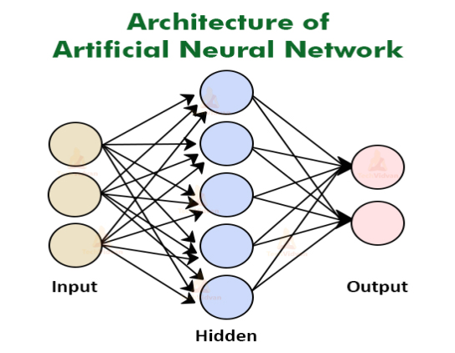

Fig 2. 1 Structure of ANN

If both of them are the same, the machine is validated. Backpropagation is used to go back through the layers and adjust the mathematical equation and update its learning if it is erroneous. Working procedure as follows [20]:

* In the first stage, input units are transferred to the hidden layer, i.e. data with some weights attached.
* Neurons make up each hidden layer.
* All calculation is done in the hidden layer after the inputs are passed on (Blue oval in the picture)

The neural network in the human brain is thought to be the inspiration for the operation of ANN. ANN is based on a concept known as Hidden State. Neurons are analogous to these hidden states. Each of these concealed states is a temporary state with a probabilistic behavior. A grid of concealed states serves as a link between the input and output. Let's try to figure out what the diagram above signifies. We have a vector of three inputs and want to know if the output event will be classified as class 1 or class 2. We need to forecast a succession of hidden classes in between for this prediction (the bridge). The likelihood of activation of hidden nodes is predicted by the vector of the three inputs in some combination between 1 and 4. The activation rate of hidden nodes 5-8 is then predicted using the probabilistic combination of hidden states 1-4. These hidden nodes 5-8 are then utilized to forecast hidden nodes 9-12, and the outcome is eventually predicted. The algorithm may learn from each prediction thanks to the intermediary latent states.

## **2.3.4 CNN - Convolutional Neural Network**

A Convolutional Neural Network (CNN) is a kind of neural network which work in exclusively garbling data using a grid like architectonics, like an image. A binary delineation of an optical data is a digital image. It is made up of a grid of pixels with pixel values defining how bright and what color each pixel should be. Our brain evaluates a vast amount of data the moment we perceive an image. Each neuron does have its own perceptron, which is linked to the rest of the visual field by other neurons. Each neuron inside the biological imaging system responds to stimuli only in a tiny area of the visual field called the receptive field, and each neuron in a CNN analyzes data only in its receptive area. Layers with simpler patterns (lines, curves, and so on) appear first, followed by layers with more complicated patterns (faces, objects, etc.). A CNN is used to give computers vision. The following is an example of a classic CNN architecture:

**Input ->Convolution ->ReLU ->Convolution ->ReLU ->Pooling -> ReLU ->Convolution ->ReLU ->Pooling ->Fully Connected -> ReLU ->Convolution ->ReLU ->Pooling ->Fully Connected.**

We will briefly discuss these in our methodology part.

## **2.3.4.1 Working Procedure of CNN - Convolutional Neural Network**

Begins with an input image and uses a variety of filters to construct a feature map before using a ReLU function to boost non-linearity. Each feature map is given a pooling layer. The pooled photos are flattened into a single long vector [21]. “A fully connected artificial neural network into which the vector. The features are processed through the network. The final completely connected layer” [22] allows us to "vote" on the classes we're interested in. For many, many epochs, trains are propagated forward and backward. This process is repeated until we have a well-defined neural network with weights and feature detectors that have been trained. So, what exactly does that imply?

Let's take a look at how CNN picture classification works:

Let's pretend the input image is of an elephant. The convolutional layers are first applied to this image, which contains pixels. “If the image is black and white, it is read as a 2D layer, with each pixel having a value between '0' and '255,' with '0' being totally black and '255' being completely white. If it's a color image, on the other hand, the result is a 3D array with a blue, green, and red layer, each with a color value between 0 and 255” [23]. Just after software picks a reduced image, known to as the 'filter,' the reading of the matrix starts “(or kernel). The depth of the filter is the same as the depth of the input. The filter then” [23] uses the input image to execute a convolution movement, moving one unit along the image. After that, the values are multiplied by the picture's original values. To get a single number, all of the multiplied figures are added together. The cycle is continued for the entire image, yielding a smaller matrix than the source image. The final array of an activation map is the feature map. “Convolution helps with tasks like edge detection, sharpening, and blurring by applying several filters to a picture” [23]. All that is necessary is the declaration of characteristics like filter size, filter number, and/or network design. This operation is similar to recognizing the basic colors and edges of an image from a human perspective. To identify the image and determine the qualities that distinguish it from a cat, for example, unique features such as the elephant's big ears and trunk must be identified. The non-linear and pooling layers are used here. “It uses the image's measurements (height and width) to gradually shrink the input image's size so that the items in the image may be spotted and identified no matter where they are” [23]. Pooling also aids in the prevention of 'overfitting,' which occurs when there is too much data and no room for new ones. “Max pooling, in which the image is separated into a succession of” [22] non-overlapping sections, is perhaps the most popular example of pooling. It uses the image's measurements (height and width) to gradually compress the input image's size, allowing the elements in the image to be seen and identified regardless of their location. Pooling also helps to avoid 'overfitting,' which occurs when there is too much data and not enough space for new ones. “The most common type of pooling is max pooling, in which the image is divided into a series of non-overlapping” [23] portions.

## **2.3.4.2 1D and 2D CNN**

Regardless of whether they have one, two, or three dimensions, CNNs operate in a similar manner. “The main difference is the structure of the input data and how the filter, also known as a convolution kernel or feature detector, travels through it” [21].

The kernel of a 1D CNN goes in one direction across the input data. The model takes one-dimensional data sequences as input and extracts characteristics from the data to map the sequences' intrinsic features. CNNs with 1-dimensional neural layers excel in extracting functionalities from a straight-length component of a huge dataset, where the feature's position isn't as important. Audio signals, sensor data, and natural language processing are just a few examples (NLP). The kernel of a 2D CNN moves in two directions across the input data. The model is fed two-dimensional input data that represents the pixels and color channels of an image. Images with two or three color channels are analyzed by CNNs with two-dimensional or even three-dimensional layers. For example, consider a color image with pixel values for each of the three layers: red, blue, and green.

# **Chapter 3**

# **Methodology**

Our presented COVID-19 detection model incorporates three phases. The first part of our work is dataset formation phase. After formatting the dataset, we used the dataset to train our Convolutional Neural Network (CNN) model, and in the classification phase, we received the result (COVID positive/Normal).

## **3.1 Proposed Workflow**

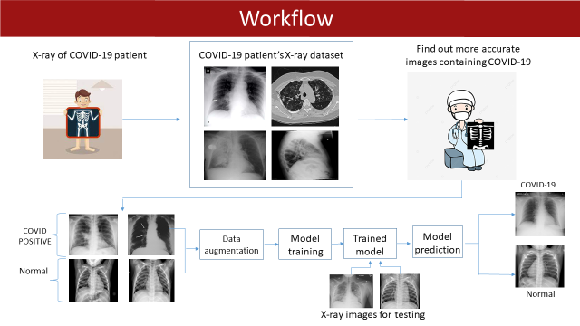

Fig 3. 1 Proposed Workflow

## **3.2 Dataset Collection**

In the experiment of this study, we used 930 X-ray images of COVID-19 positive patients and 930 X-ray images of Normal people or patients with other diseases. Due to the shortage of datasets, getting a promising result was very tough. We used data pre-processing techniques like normalization, mostly data augmentation to deal with it. “The main dataset sources are used in this study are enlisted as follows:

1. The first dataset of COVID-19 patients was collected from GitHub. The data was gathered from several hospitals and clinics by the University of Montreal's Ethics Committee no. CERSES-20-058-D” [1]. It is an open source GitHub repository which is updating almost every day and the dataset is getting bigger [24].

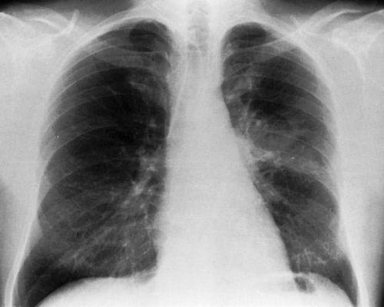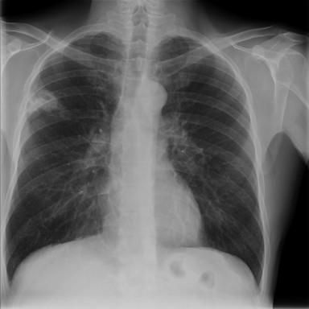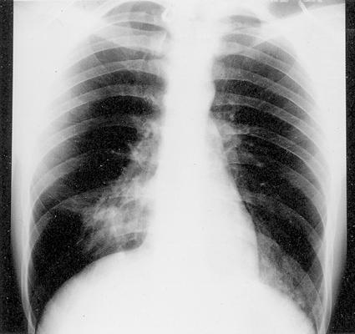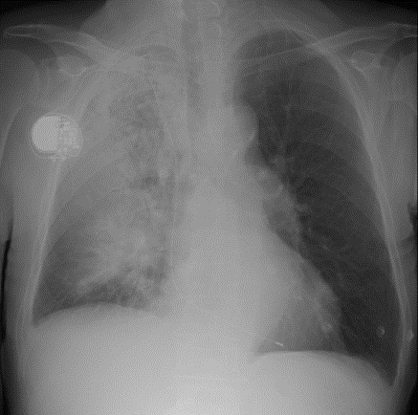 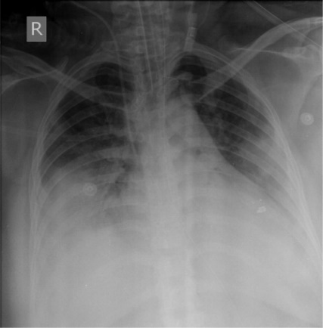 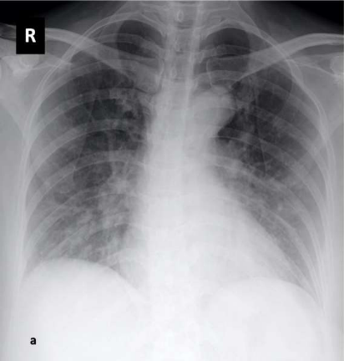

Fig 3. 2 COVID-19 Positive X-ray Images

1. For regular chest X-ray images, a dataset from Kaggle was collected [25].

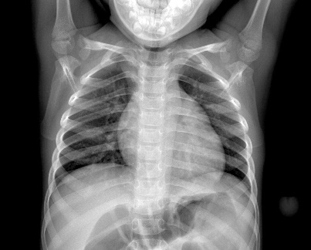 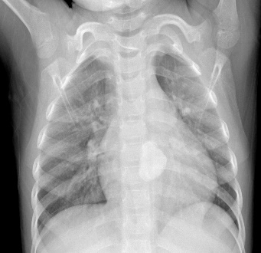 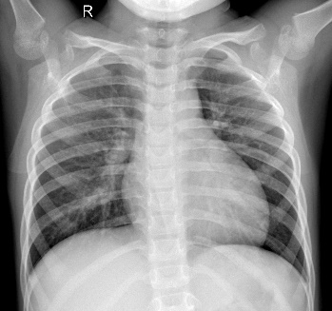 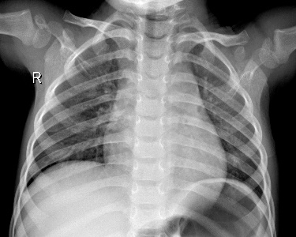 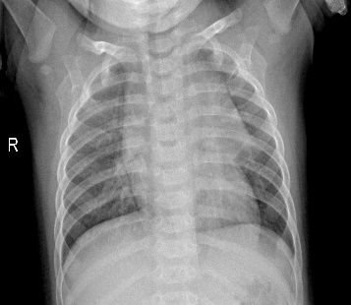 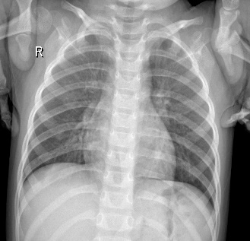

Fig 3. 3 Normal Patient’s X-ray images

The experiment has been done on Google Colab notebook.

## **3.3 Dataset Pre-Processing**

Our proposed model is based on COVID-19 detection using X-ray images, but the chest x-ray images of COVID-19 positive patients is not available on internet is much more. To achieve a promising result from CNN model, big amount of data is needed. Due to our limitations of collecting the enough amount of data, we have done some pre-processing techniques to make bigger our dataset. We’ve done data augmentation, normalization pre-processing techniques.

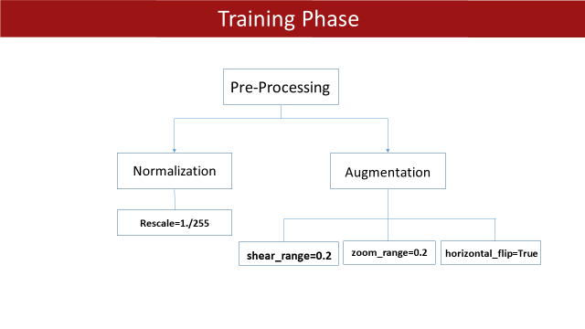

Fig 3. 4 Dataset Pre-processing

## **3.3.1 Data Normalization**

Normalization is a data preparation technique that is often used in machine learning. The process of changing the columns of a dataset to the same scale is known as normalization. The normalization of every dataset is not required for machine learning. It is simply required when the ranges of characteristics are different. Normalization is the process of changing data into a dimensionless state or one with similar distributions. Standardization, feature scaling, and other labels for this normalization technique exist. For any machine learning application or model fitting, normalization is a critical step in data pre-processing. Model accuracy is greatly improved by data normalization. “Normalization assigns equal weights/importance to each variable, ensuring that no single variable biases model performance in one direction just because it is larger” [22]. Distance measures, for example, are used by clustering algorithms to assess whether or not an observation belongs in a particular cluster. The "Euclidean distance" is widely used to measure these distances. Distance measures can be dominated by a variable with extremely high values, thereby suppressing low-valued variables.

## **3.3.1.1 Normalization Techniques**

Normalization can be accomplished in a variety of ways, however the following are three of the most prominent and widely used methods:

* Rescale: The simplest of all approaches, rescaling (also known as "min-max normalization"), is calculated as [22]:

* “Mean normalization: This method uses the mean of the observations in the transformation process” [22]:
* Z-score normalization: “Also known as standardization, this technic uses Z-score or standard score. It is widely used in machine learning algorithms such as SVM and logistic regression” [22]:

“Here, z is the standard score, µ is the population mean and ϭ is the population standard deviation” [22].

We rescaled our data in the size of 1. /255. To rescale 1. /255, change every pixel value from [0,255] to [0,1]. The advantages are as follows: Treat all photographs the same: some have a high pixel range, while others have a low pixel range.

## **3.3.1.2 Data Augmentation**

Making copies of existing data and making minor changes to them is one technique to increase the diversity of the training dataset. "Data augmentation" is the term for this. If a dataset is small, even a version enhanced with rotation, mirroring, and other effects may not be adequate to solve a problem. Another option is to employ various approaches to generate wholly new, synthetic photos, such as using generative adversarial networks to generate new synthetic images for data augmentation.  Furthermore, picture recognition algorithms perform better when transferring data from virtual environments to real-world data. Our COVID-19 X-ray dataset wasn’t big enough, that’s why we used shear augmentation, zoom and flipping techniques. These are top data augmentation techniques:

* Adding noise
* Cropping
* Flipping
* Rotation
* Scaling
* Translation
* Brightness
* Contrast
* Color Augmentation
* Saturation

## **3.4 Convolutional Neural Network**

A convolutional neural network, or CNN, is a deep learning neural network that evaluates organized arrays of data, such as presentations. CNNs are excellent at detecting design elements in input images, such as lines, gradients, circles, and even eyes and faces. In this project CNN has an important role to play. We have used multiple convolutional layers to complete our project.

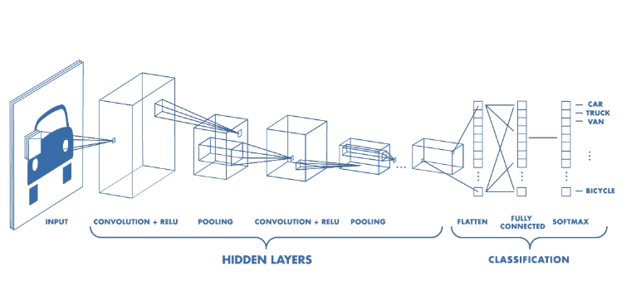

Fig 3. 5 Architecture of a CNN

## **3.4.1 The Proposed CNN Architecture**

“The proposed CNN model consists of multiple layers in which 4 are convolutional (Conv2D), 4 max pooling layers, 4 dropout layers, activation function layers, batch normalization layers,1 flatten layer, and 3 fully connected layers” [1].

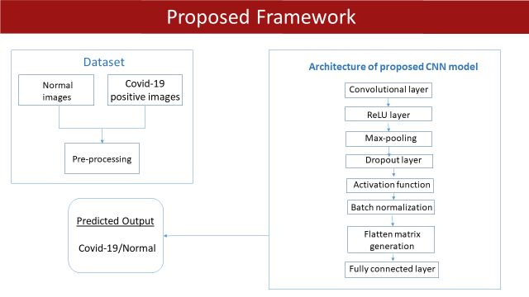

Fig 3. 6 Proposed CNN Architecture

## **3.4.1.1 Convolutional Layer**

The CNN's most essential part is the convolution layer. It is in control of the bulk of the processing power on the network. This layer does a linear combination among two matrices, one being the restricted area of the perceptron and the other a set of learnable parameters called a kernel. Despite its modest size, the kernel has more complexity than an image. If the image has three (RGB) channels, the kernel height and width will be minimal, however the depth will span all three. Convolution is a method of combining two sources of data in an orderly manner; it is a transformation from one function to another. Convolutions have long been employed in image processing to blur and sharpen images, but they're also used elsewhere applications. CNNs enforce the leased line arrangement between neurons in surrounding layers.

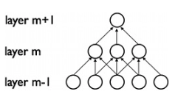

Fig 3. 7 Convolutional Layer

We can use different kinds of convolutions [26]. These are:

* **The 2D Convolutional Layer:** The 2D convolution layer, which is commonly abbreviated as conv2D, is the most common type of convolution used. By "rolling" across the 2D raw data in a conv2D layer, a filter or kernel conducts mechanical amplification. As a result, all of the output pixels will be merged into one. The kernel will repeat the algorithm for each point it slides over, converting a 2D matrix of properties into a 2D matrix of features.
* **The Dilated or Atrous Convolution**: By injecting zero-values into convolution kernels, this procedure increases window size without increasing the number of weights. Dilated or atrous convolutions can be employed in real-time applications as well as applications with lower computing power and RAM needs.
* **Separable Convolutions:** Separable convolutions are divided into two categories: spatial separable convolutions and depth wise separable convolutions. The spatial separable convolution is primarily concerned with the image and kernel's spatial dimensions: width and height. Unlike spatially indistinguishable convolutions, depthwise convolutions function with kernels which can't simply "taken into account" into two smaller kernels. As a result, it is being utilized more frequently.
* **Transposed Convolutions:** Deconvolutions or fractionally strided convolutions are other names for these forms of convolutions. A typical convolution is performed by a transposed convolutional layer, but the spatial change is reversed.

We have used four 2D convolutional layers. The four layers were named by “conv2d”, “conv2d_1”, “conv2d_2”, “conv2d_3”. These Conv2D layers consists of different filters. “Convolutional layers are strong feature extractors in which the convolutional filters are capable of finding features of images” [5]. We used filters in these numbers:

* Conv2d=32 filters
* Conv2d_1=32 filters
* Conv2d_2=64 filters
* Conv2d_3=128 filters

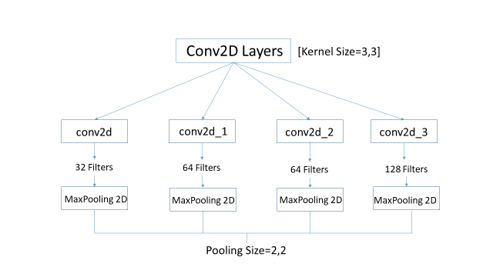

Fig 3. 8 Proposed CNN layers

## **3.4.1.2 Kernel Size**

Kernel sizes for convolutional layers are generally one, three, or five, and yet we unearthed that numerous sprints characterized a kernel size distribution for the the last convolutional layer with a peak at 7 or 9; a prior brute-force homogeneous grid search of optimal hyper-parameters for the same CNN found kernel sizes of one, three, or five. Our Kernel size was (3, 3) which is considered as standard size in these days.



Fig 3. 9 Kernel Size

## **3.4.1.3 Polling Layers**

After each CONV2D layer, with a pooling size of 2*2, we employed the max pooling layer. A pooling layer is some other ingredient of a CNN. Its characteristic is to step by step limit the spatial measurement of the illustration to reduce the amount of parameters and computation in the network. Pooling layer operates on every characteristic map independently. A common CNN model architecture is to have a number of convolution and pooling layers stacked one after the other. “By compressing or generalizing the features in the feature map, it essentially aids in the reduction of overfitting by the model's training time .Because they frequently use the maximum or average values of input to down sample the data, pooling layers are fairly simple. The pooling operation is mathematically described as sliding a two-dimensional filter through a three-dimensional feature map and summarizing the features that get in the way of the filters. So, if a feature map with dimensions of h * w * c is supplied, the pooled output will be” [27]:

“(h – f+ 1)/ s * (w – f + 1) * c

Where,

* h and w are the height and width of the feature map respectively
* c is the channel presented in the feature map
* f is the size of the filter
* s is stride length” [27]

## **3.4.1.4 Types of Pooling Layers**

“Pooling layers are roughly divided into four kinds:

* Max pooling layer.
* Min pooling layer
* Average pooling layer
* Global pooling layer” [27]

**Max Pooling Layer:** “The layer uses the most significant feature of the feature map produced by the convolutional layer in max-pooling. In a nutshell, it selects the highest valued element in any feature map from the region covered by the filter.

The image below represents the operation of the max-pooling layer with a 2-dimensional feature map” [27]:

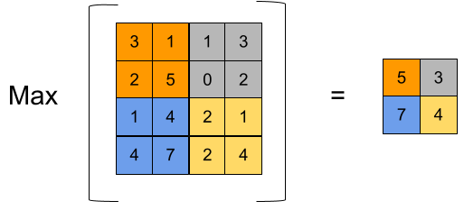

Fig 3. 10 Max Pooling Layer

“Consider the image on the left, which has 4*4 dimensions and is a feature map with a written value; when the max-pooling layer is applied to the map layer, a feature map of dimensions 2*2 is generated. The layer will choose the highest value from each patch. This will make it easier for the remainder of the model to interpret the data and perform calculations on it, making the entire process more resilient than previously.

Max polling aids in the extraction of low-level features from data, such as edges and points, or, in the case of image processing, max-pooling aids in the extraction of the sharpest features on the picture, which are the best lower-level representation of the image” [27].

**Min Pooling Layer:** In min pooling, the layer works with the feature map provided by the convolutional layer's least prominent feature. In a nutshell, it selects the lowest valued element in any feature map from the region recorded by the filter.

“The operation of the min pooling layer with a 2-dimensional feature map is depicted in the graphic below” [27]:

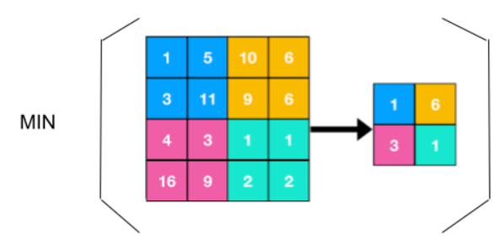

Fig 3. 11 Min Pooling Layer

“Consider the image on the left, which has 4*4 dimensions and is a feature map with a written value; when the min pooling layer is applied to the map layer, a feature map of dimensions 2*2 is generated. The layer will choose the lowest value from each patch” [27]. As seen in the example image above, we utilize min pooling to extract the most irrelevant features from the data, or [27] in the case of image data, it aids in the extraction of features with lower sharp values or edgeless features from the image.

**Average Pooling Layer:** The layer selects the average values of the elements accessible in the patch of the feature map when using average pooling. “Essentially, the entire feature map is downsampled to the average value obtained by the feature map's region. As a result, the max-pooling feature of any patch is revealed, whereas the average pooling feature reveals the average of the covered area.

The image below shows an example of average pooling of a 4*4 image using a 2*2 feature map in the pooling layer” [27]:

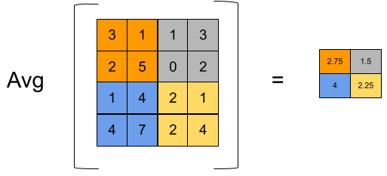

Fig 3. 12 Average Pooling Layer

“Consider the image on the left, which has 4*4 dimensions and is a feature map with written value; when the average pooling layer is applied to the map, the layer generates a feature map with dimensions 2*2. The layer will choose the highest value from each patch” [27]. We get some translation invariance through pooling. Pooling also takes less time to compute than convolutions. Average pooling aids in the extraction of smooth features. “If we apply the average pooling layers to picture data, we will receive the combination of all colors presented in the region covered by the feature map. So, if the distribution of data points and colors in any image is smooth or, to put it another way, if the distribution is correct, we may utilize Average pooling to get good results” [27].

**Global Polling Layer:** “The global pooling layer takes the average or maximum of the feature map, and the resulting vector can be immediately fed into the softmax layer, preventing overfitting. The global pooling layer can be divided into two categories:

* Global Average Pooling
* Global Max Pooling

A global average layer can be used instead of the flatten layer to avoid overfitting the CNN, and a global maximum pooling layer can also be used instead of the flattening layer” [27].

## **3.4.1.5 ReLU Layer**

“A Rectified Linear Unit (ReLU) is a non-linear activation function that performs on multi-layer neural networks. (e.g., f(x) = max (0,x) where x = input value). A ReLU function performs element-wise operation. This function has an output that is a rectified feature map” [28]. “Every negative value in the filtered image is removed and replaced with zero in this layer. When the node input exceeds a particular threshold, this function is activated. As a result, when the input is less than zero, the output is also zero. When the input exceeds a particular threshold, however, the dependent variable and the input have a linear relationship. This means it can increase the speed of a training data set in a deep neural network faster than other activation functions, avoiding summing with zero” [29].

## **3.4.1.6 Dropout Layer**

“The dropout layer has been used with 25% dropout rate. In a neural network, dropout is implemented per layer. Most types of layers, including dense fully connected layers, convolutional layers, and recurrent layers like the long short-term memory network layer, can be utilized with it. Dropout can be used on any or all of the network's hidden layers, as well as the visible or input layer. On the output layer, it isn't used” [1].

## **3.4.****1.7 Batch Normalization Layer**

Batch normalization is a network layer that enables each layer to learn more independently from the others. It's being used to render the prior layers' output more natural. The activations in normalization scale the input layer. After the hidden layer and before the output layer, a new Batch Normalization layer can be added to the model. Specifically, after the previous concealed layer's activation function.

Instead of using the entire data set, it is done in mini-batches. Its purpose is to facilitate learning by speeding up training and utilizing higher learning rates. the output standard deviation of the neurons

Where x* is the new value of a single component, E[x] is its mean within a batch, and var(x) is its variance within a batch, the basic formula is x* = (x - E[x]) / sqrt(var(x)). The formula is extended by BN to x** = gamma * x* + beta, where x** is the final normalized value. Gamma and beta are taught on a layer-by-layer basis. Internal covariate shift is a major problem that batch normalization overcomes. It aids by improving the appearance of data flowing between intermediate layers of the neural network, allowing you to use a faster learning rate. It has a regularizing effect, so you can usually avoid dropping out. These parameters are used to rescale () and shift () the vector containing the results of preceding operations. These two parameters are learnable, and the neural network ensures that the best values of and are chosen throughout training. This will allow each batch to be accurately normalized. The following are the benefits of batch normalization:

• Quickens the training process

• Handles internal covariate shift

• Internal covariate shift

• Smoothes the loss function

## **3.4.1.8 Flatten Layer**

The process of flattening data into a one-dimensional array for usage in the following layer is known as flattening. We compress the output of the convolutional layers to create a single long feature vector. It's also connected to the final categorization model, known as a fully-connected layer.

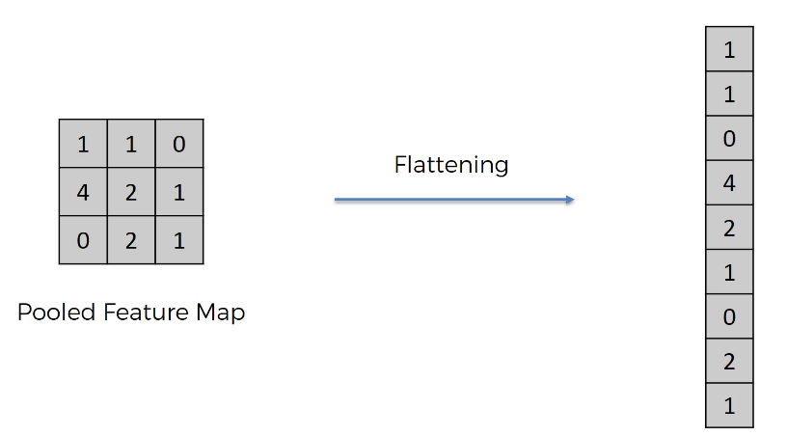

Fig 3. 13 Flatten Layer

## **3.4.1.9 Fully Connected Layer**

Pull forward neural networks are the focus of the Fully Connected Layer. The Fully Connected Layers are the network's final levels. The output of the fully connected layer is the result of the final Pooling or Convolutional Layer, which is flattened before being fed into the fully connected layer. The output of the convolutional layers represents the high-level features of the data. Whereas the output layer could be flattened and linked to the output layer, introducing a fully-connected layer allows you to learn non-linear combinations of these characteristics for a (usually) low cost. The fully-connected layer develops a (perhaps non-linear) function within this field, and the convolutional layers produce a coherent, reduced, and fairly invariant subspace. We don't need to undertake any feature engineering since CNNs capture superior representations of the data. We must categorize the data into several classes after feature extraction, which we may do with a fully connected (FC) neural network.

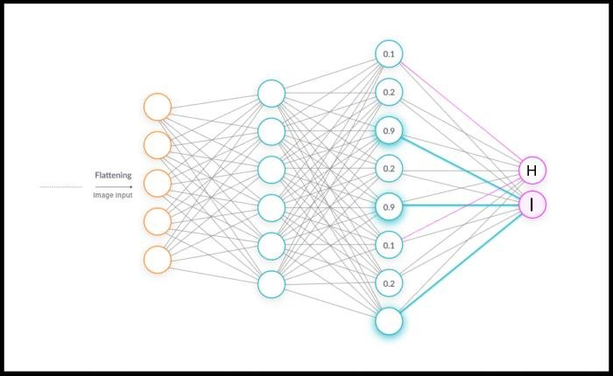

Fig 3. 14 Fully Connected Layer

## **3.5 ML Tools We’ve Used**

We have used bunch of machine learning tools to design our model, pre-process our dataset and to show the output of our proposed model. Here is the list of the tools:

* Python
* NumPy
* Keras
* Tensorflow
* Matplotlib

## **3.5.1 Python**

Python is a programming language used to construct websites and apps, automating activities, and conduct analysis of data. Python is a general-purpose programming language, meaning it can be used to create a variety of applications and isn't focused on a single problem. It has been one of the most extensively used programming languages nowadays high accuracy and beginner-friendliness. It will be the most popular programming language among developers in 2020, according to RedMonk, an industry analyst firm.[30].

Python is widely used for web and software development, task automation, data analysis, and data visualization. Python has been used by many non-programmers, such as accountants and scientists, for a variety of common tasks, such as arranging finances, due to its relative ease of learning.

## **3.5.2 NumPy**

“NumPy is a Python module that allows you to interact with arrays. It also provides functions for working with matrices, fourier transforms, and linear algebra. Travis Oliphant invented NumPy in 2005. It is an open source project that you are free to use. Numerical Python is referred to as NumPy. We have lists in Python that act as arrays, however they are slow to process. NumPy intends to deliver a 50-fold quicker array object than ordinary Python lists. The array object in NumPy is named ndarray, and it comes with a slew of helper functions to make working with it a breeze. In data research, when speed and resources are critical, arrays are widely employed” [31] .

## **3.5.3 Keras**

Keras is a deep learning API written in Python that works on top of the TensorFlow machine learning framework. It was developed with the purpose of facilitating speedy exploration. When carrying out a research, it's important to be able to move rapidly from concept to conclusion. Keras is a greater deep learning API for creating neural networks designed by Google. It is written in Python which is used to simplify the implementation of neural networks. It also enables for the backend calculation of several neural networks. Keras is a powerful and simple-to-use Python framework for creating and analyzing deep learning models. It introduces Theano and TensorFlow, two powerful numerical computation tools that allow you to create and validate neural network models with just a few lines of code.

## **3.5.4 Tensorflow**

TensorFlow, a Python library for fast numerical computing, was created and released by Google. It's a foundational library for developing Deep Learning models, either directly or through wrapper libraries developed on atop of TensorFlow to ease the process. Programmers may use it to create large-scale neural networks with several layers. TensorFlow is commonly used for classification, perception, comprehension, discovery, prediction, and invention. With tools like the Keras Functional API and Model Subclassing API, TensorFlow offers you the flexibility and control you need to construct complex topologies. For speedy prototyping and debugging, use eager execution. TensorFlow supports APIs in several languages for both producing and running TensorFlow graphs. Although the Python API is presently the most comprehensive and user-friendly, other language APIs may be easier to integrate into applications and give performance improvements in graph execution.

## **3.5.5 Matplotlib**

Matplotlib is a Python data visualization library that is frequently used. It's a cross-platform library that turns array data into 2D charts. It gives a Python GUI toolkits like PyQt and WxPythonotTkinter with an object-oriented API for integrating graphs. Matplotlib is a cross-platform data visualization and graphical plotting tool for Python and its numerical package NumPy. As a result, it allows MATLAB to replace the current source with a flow source. Matplotlib's APIs (Application Programming Interfaces) can also be used to integrate charts into graphical user interfaces. It's a graphing library for the Python programming language and NumPy, the Python numerical mathematics extension.

# **Chapter 4**

# **Result & Discussion**

## **4.1 Tools and Languages**

The Python programming language was used to create our proposed model because it is one of the most accessible and user-friendly programming languages available today[32]. We selected TensorFlow [33], an open source framework for deep learning applications, because we were working with CNN, a deep learning technique. Keras was utilized to give our neural network a Python interface [34]. It's a Python module that aids in the creation and testing of deep learning models. For improved data visualization, we used Matplotlib. It's a library for graphical plotting [35]. Our experiment was carried out with Google Colab, a web-based Python editor that allows anyone to develop and run Python code. Machine learning, data analysis, and education are all areas where it comes in handy. [36].

## **4.2 Dataset**

The final dataset consisted of 1860 X-ray pictures after preprocessing. 930 were normal images and 930 images were from the COVID-19 positive patient’s X-ray. The dataset was divided into two subgroups for training and testing the proposed CNN. A total of 1360 X-ray images were included in the training dataset, which included 680 COVID-19 X-ray images and 680 normal X-ray photos. Similarly, the testing dataset includes 500 X-ray images, including 250 X-ray images from each COVID-19 positive and normal class [1]. These datasets were collected from Kaggle [25] and an open source GitHub repository [24].

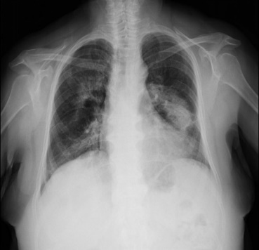  

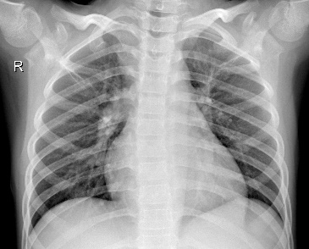 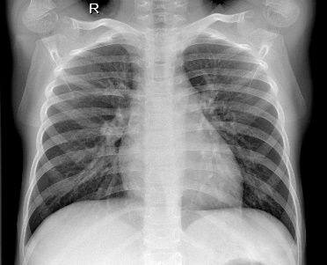 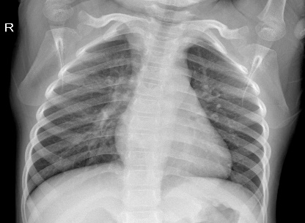

Fig 4. 1 COVID-19 positive and normal dataset

## **4.3 Performance Analysis**

Overall performance of our proposed model can be evaluated from training, testing accuracy and loss. We can also predict a final result with the help of confusion matrix. These criteria provide insight into the system's ability to provide accurate results.

## **4.3.1 Confusion Matrix**

A confusion matrix is a tool for describing how well a classification algorithm performs. A confusion matrix is a table that is commonly used to assess a classification model's or classifier's performance on a set of test data for which the true characteristics are known. It allows you to see how well an algorithm performs. It makes it easier to distinguish between two classes, for example, when one class is frequently mislabeled as the other. The confusion matrix is utilized to compute the majority of performance metrics. The confusion matrix depicts the mechanisms that cause the classification model to produce incorrect predictions. It tells us not just about the sorts of mistakes a classifier produces, but also about the types of errors a classifier makes. The confusion matrix determines the framework's correctness, sharpness, recall, and f-measure.

The steps for calculating a confusion matrix are outlined below [37]:

1. It's necessary to have a test dataset or a validation dataset with anticipated relevant.

2. For every row in our validation dataset, this will make a prediction.

3. The expected outcomes and projections are as follows:

(1) For each class, the number of correct guesses.

(2) The overall number of wrong guesses, broken down by predicted class.

In confusion matrix, we find these cases:

* “True Negative: Model has given prediction No, and the real or actual value was also No.
* True Positive: The model has predicted yes, and the actual value was also true.
* False Negative: The model has predicted no, but the actual value was Yes, it is also called as Type-II error.
* False Positive: The model has predicted Yes, but the actual value was No. It is also called a Type-I error.” [38]

These are the calculations are used for confusion matrix [38]:

**Classification Accuracy: “**Classification accuracy is one of the most important criteria for measuring the correctness of classification tasks. It indicates how often the model predicts the outcome properly. It is possible to calculate the ratio of the number of correct predictions made by the classification to the overall number of predicted by the classifiers. The formula is as follows” [38]:

**Misclassification Rate:** “It's also known as the error rate, because it describes how frequently the model makes incorrect predictions. The number of inaccurate predictions divided by the total number of predictions made by the classifier is the error rate. The formula is as follows” [38]:

**Precision:** It is the number of true outputs provided by the system or the proportion among all positive classes properly forecasted as genuine by the model. The formula given below can be used to compute it:

**Recall:** It's the percentage of positive classes out of a total of positive classes that our model properly predicted. It is vital to get the highest possible recall rate.

**F-measure:** It's difficult to compare two models with poor accuracy but good recall, or vice versa. As a consequence, we may do this using F-score. This score may be used to assess both recall and precision at the same time. When recall and accuracy are equal, the F-score is maximum. The formula below can be used to compute it. [38].

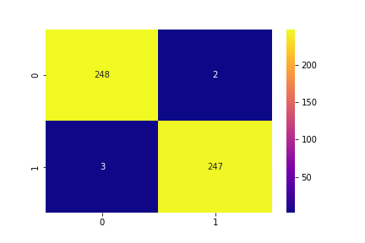

Fig 4. 2 Confusion Matrix prediction graph

In our experiment, we have given total 500 images for testing. 250 images were COVID-19 positive and other 250 were normal images. We denoted COVID positive cases with 0 and Normal cases with 1. Here top-left values are true-positive values. These value should be higher and close to 250 for a better accuracy. We found the value 248 in here, that means 248 COVID-19 positive cases out of 250 cases were truly detected. Top-right values are false negative. That means it indicates the values which are COVID-19 positive, but it predicted negative by the machine. In our case false negative value is 2. This value should be close to 0 for a better accuracy. Bottom-left values are false positive. We got 3 false positive values. These are the cases from normal patients but the machine falsely detected it as COVID-19 positive. This value also should be close to 0. The other side in the figure, the cases are true negative. These 247 cases are from normal patients and truly detected as normal as well.

## **4.3.2 Accuracy and loss graphs**

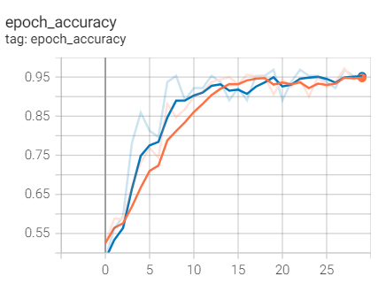

Fig 4. 3 Training and Validation accuracy

This graph shows the accuracy of training and validation. The epochs are represented on the X-axis, while the accuracy is represented on the Y-axis in the graph above. Blue color line is denoted training and yellow line is for validation. We have got 96.88% of accuracy in our model.

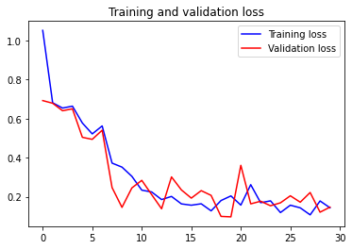

Fig 4. 4 Training and validation loss

In the above figure X-axis represents the epochs and Y-axis represents loss.

## **4.4 Comparison with other methods**

This section compares the suggested method to “recent state-of-the-art technologies for COVID-19 detection using” [2] radiological imaging such as CXR and chest CT. The image collection dataset created by Dr. Cohen was used in the majority of the experiments [39]. “This was the first open source dataset that researchers could utilize to extract relevant patterns from CXR and chest CT pictures for COVID-19 identification. suggested a transfer learning-based pre-trained network VGG19 for COVID-19 detection from CXR images [40]. Researchers employed 224 COVID-19 CXR pictures, 700 images of viral pneumonia, and 504 images of normal or healthy cases in this study. For a three-class problem, their model had an accuracy of 93.48 percent. [41] Used a deep ResNet pre-trained network to extract top K features from chest CT images using a mix of Attention and Feature Pyramid Network (FPN). With 777 COVID-19 photos and 708 healthy images” [2], they were able to obtain an accuracy of 86% in this investigation. Researchers have utilized various combinations of transfer learning approaches to solve the binary classification problem.[42] Used three pre-trained networks (ResNet50, InceptionV3, and InceptionResNetV2), with ResNet50 outperforming the others with a 98 percent accuracy rating. “Researchers used 50 CXR images of COVID-19 positive patients and 50 images of COVID-19 negative patients in this study” [2].

[42] For recognizing COVID-19 in CXR images, I created the DarkCovidNet deep CNN model. They used the DarkNet-19 [43] architecture to create the model, which had a multi-class accuracy of 87.02 percent and a two-class accuracy of 98.08 percent [2].

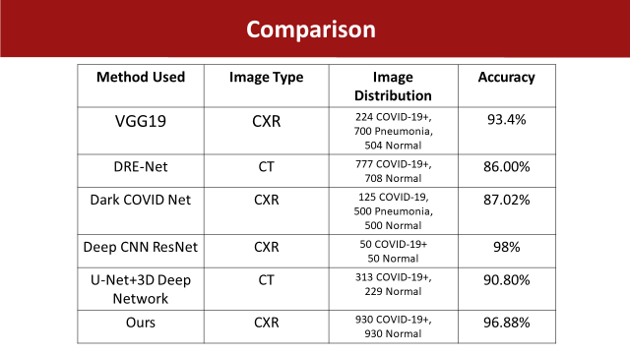

Table 4. 1 Comparison with other methods

[43] Used 313 COVID-19 chest CT images and 229 healthy cases to create a “three-dimensional CNN model with a pre-trained network U-Net. They claimed a 90.8 percent accuracy rate” [2]. Our method has gained an accuracy of 96.88%. We used 930 COVID-19+ and 930 normal images.

# **Chapter 5**

# **Conclusion and Future Work**

The goal of this work was to show that utilizing CNN trained on chest X-ray image datasets, COVID-19 could be identified effectively and accurately. To achieve the best accuracy and performance, the model was gradually trained with a range of datasets. The initial dataset was small, with an unbalanced distribution of classes. These two faults in the source dataset seriously affected the models' performance. To address these concerns, the dataset was preprocessed utilizing a variety of techniques, including dataset balance, manual X-ray picture analysis, and data augmentation techniques. The performance results were presented after training and testing the CNN model on the whole processed dataset. The progressive strategy used in this study to train the model using various amounts and types of datasets confirmed the hypothesis that CNN models require a large amount of visual input to be effective and reliable. By generating more data from a small dataset and giving CNN invariance, data augmentation procedures are particularly useful in dramatically boosting CNN model performance. The proposed CNN model's number of convolutional layers was also determined incrementally; that is, just one convolutional layer has been used in the first ascent, and afterwards one layer was decided to add in each increment based on model performance metrics until in terms of performance, the model has reached a steady and efficient stage. To further assess the scope of the proposed CNN model, it was compared to some of the most popular machine learning models, including VGG19, DRE-NET, Dark COVID Net, Deep CNN ResNet, and U-Net+ 3D Deep Network. The proposed CNN beat all other models, according to the data.

Our research is based on medical data. That’s why it is very sensitive. Even a small number of false positive or false negative result can make a big impact on human body. Our goal is to train the model more efficiently in future and turn down false results to zero. In future days, the dataset of COVID-19 patients will be more available and we can increase our dataset. It is well proved that, large number of dataset can make a significant improvement in model accuracy. We hope we can make our model 100 percent accurate in future days and this will be very helpful for medical image processing.

# **References**

[1] A. A. Reshi *et al.*, “An Efficient CNN Model for COVID-19 Disease Detection Based on X-Ray Image Classification,” *Complexity*, vol. 2021, 2021, doi: 10.1155/2021/6621607.

[2] M. Siddhartha and A. Santra, “COVIDLite: A depth-wise separable deep neural network with white balance and CLAHE for detection of COVID-19,” Jun. 2020, doi: 10.48550/arxiv.2006.13873.

[3] A. A. Reshi *et al.*, “An efficient CNN model for COVID-19 disease detection based on X-ray image classification,” *Complexity*, vol. 2021, 2021.

[4] G. Litjens *et al.*, “A survey on deep learning in medical image analysis,” *Med. Image Anal.*, vol. 42, pp. 60–88, 2017.

[5] A. Abdelrahman and S. Viriri, “Kidney Tumor Semantic Segmentation Using Deep Learning: A Survey of State-of-the-Art,” *J. Imaging 2022, Vol. 8, Page 55*, vol. 8, no. 3, p. 55, Feb. 2022, doi: 10.3390/JIMAGING8030055.

[6] X. Tang, “The role of artificial intelligence in medical imaging research,” *BJR open*, vol. 2, no. 1, p. 20190031, Nov. 2019, doi: 10.1259/BJRO.20190031.

[7] X. Tang, “The role of artificial intelligence in medical imaging research,” *https://doi.org/10.1259/bjro.20190031*, vol. 2, no. 1, p. 20190031, Nov. 2019, doi: 10.1259/BJRO.20190031.

[8] J.-G. Lee *et al.*, “Deep learning in medical imaging: general overview,” *Korean J. Radiol.*, vol. 18, no. 4, pp. 570–584, 2017.

[9] C. D. Lehman *et al.*, “Diagnostic accuracy of digital screening mammography with and without computer-aided detection,” *JAMA Intern. Med.*, vol. 175, no. 11, pp. 1828–1837, 2015.

[10] D. Ardila *et al.*, “End-to-end lung cancer screening with three-dimensional deep learning on low-dose chest computed tomography,” *Nat. Med.*, vol. 25, no. 6, pp. 954–961, 2019.

[11] H. Wang *et al.*, “Mitosis detection in breast cancer pathology images by combining handcrafted and convolutional neural network features,” *J. Med. Imaging*, vol. 1, no. 3, p. 34003, 2014.

[12] T. O. Ayodele, “Machine learning overview,” *New Adv. Mach. Learn.*, vol. 2, 2010.

[13] “Top 10 Machine Learning Applications and Examples in 2022.” https://www.simplilearn.com/tutorials/machine-learning-tutorial/machine-learning-applications (accessed Mar. 12, 2022).

[14] “What is Deep Learning and How Does It Works [Updated].” https://www.simplilearn.com/tutorials/deep-learning-tutorial/what-is-deep-learning (accessed Mar. 14, 2022).

[15] S. Ray, “A quick review of machine learning algorithms,” in *2019 International conference on machine learning, big data, cloud and parallel computing (COMITCon)*, 2019, pp. 35–39.

[16] A. Abed, E. Fawzi, and S. S. A. Naser, “Retina Diseases Diagnosis Using Deep Learning,” *Int. J. Acad. Eng. Res.*, vol. 6, pp. 11–37, 2022, Accessed: Mar. 13, 2022. [Online]. Available: www.ijeais.org/ijaer.

[17] A. Fourcade and R. H. Khonsari, “Deep learning in medical image analysis: A third eye for doctors,” *J. Stomatol. oral Maxillofac. Surg.*, vol. 120, no. 4, pp. 279–288, 2019.

[18] “Top 20 Deep Learning Projects With Source Code (2022) - InterviewBit.” https://www.interviewbit.com/blog/deep-learning-projects/ (accessed Mar. 13, 2022).

[19] L. C. Yan, B. Yoshua, and H. Geoffrey, “Deep learning,” *Nature*, vol. 521, no. 7553, pp. 436–444, 2015.

[20] M. H. Hassoun, *Fundamentals of artificial neural networks*. MIT press, 1995.

[21] H.-C. Shin *et al.*, “Deep convolutional neural networks for computer-aided detection: CNN architectures, dataset characteristics and transfer learning,” *IEEE Trans. Med. Imaging*, vol. 35, no. 5, pp. 1285–1298, 2016.

[22] “Data normalization in machine learning | by Mahbubul Alam | Towards Data Science.” https://towardsdatascience.com/data-normalization-in-machine-learning-395fdec69d02 (accessed Mar. 13, 2022).

[23] “Using Convolutional Neural Network for Image Classification | upGrad blog.” https://www.upgrad.com/blog/using-convolutional-neural-network-for-image-classification/ (accessed Mar. 13, 2022).

[24] “GitHub - ieee8023/covid-chestxray-dataset: We are building an open database of COVID-19 cases with chest X-ray or CT images.” https://github.com/ieee8023/covid-chestxray-dataset (accessed Mar. 05, 2022).

[25] “Chest X-Ray Images (Pneumonia) | Kaggle.” https://www.kaggle.com/paultimothymooney/chest-xray-pneumonia (accessed Mar. 05, 2022).

[26] “What is a Convolutional Layer? - Databricks.” https://databricks.com/glossary/convolutional-layer (accessed Feb. 18, 2022).

[27] “Comprehensive Guide to Different Pooling Layers in Deep Learning.” https://analyticsindiamag.com/comprehensive-guide-to-different-pooling-layers-in-deep-learning/ (accessed Mar. 12, 2022).

[28] “What is a ReLU layer?” https://www.educative.io/edpresso/what-is-a-relu-layer (accessed Mar. 14, 2022).

[29] K. V Spoorthi and B. S. Rekha, “Diabetic Retinopathy Prediction using Deep learning,” pp. 1–6, Jan. 2022, doi: 10.1109/CSITSS54238.2021.9683553.

[30] “The RedMonk Programming Language Rankings: January 2020 – tecosystems.” https://redmonk.com/sogrady/2020/02/28/language-rankings-1-20/ (accessed Feb. 19, 2022).

[31] “NumPy Installation - Introduction to NumPy - Numeric Python.” https://machinelearning.org.in/introduction-to-numpy/ (accessed Mar. 14, 2022).

[32] “Why Python? 7 Reasons Why Python is Popular with Developers.” https://flexisourceit.com.au/resources/blog/reasons-why-python-is-popular/ (accessed Mar. 05, 2022).

[33] “What is TensorFlow? The machine learning library explained | InfoWorld.” https://www.infoworld.com/article/3278008/what-is-tensorflow-the-machine-learning-library-explained.html (accessed Mar. 05, 2022).

[34] “Your First Deep Learning Project in Python with Keras Step-By-Step.” https://machinelearningmastery.com/tutorial-first-neural-network-python-keras/ (accessed Mar. 05, 2022).

[35] “Matplotlib Tutorial | Python Matplotlib Library with Examples | Edureka.” https://www.edureka.co/blog/python-matplotlib-tutorial/ (accessed Mar. 05, 2022).

[36] “4 Reasons Why You Should Use Google Colab for Your Next Project | by Orhan G. Yalçın | Towards Data Science.” https://towardsdatascience.com/4-reasons-why-you-should-use-google-colab-for-your-next-project-b0c4aaad39ed (accessed Mar. 05, 2022).

[37] “What is a Confusion Matrix in Machine Learning.” https://machinelearningmastery.com/confusion-matrix-machine-learning/ (accessed Mar. 05, 2022).

[38] “Confusion Matrix in Machine Learning - Javatpoint.” https://www.javatpoint.com/confusion-matrix-in-machine-learning (accessed Mar. 05, 2022).

[39] J. P. Cohen, P. Morrison, and L. Dao, “COVID-19 image data collection,” *arXiv Prepr. arXiv2003.11597*, 2020.

[40] I. D. Apostolopoulos and T. A. Mpesiana, “Covid-19: automatic detection from x-ray images utilizing transfer learning with convolutional neural networks,” *Phys. Eng. Sci. Med.*, vol. 43, no. 2, pp. 635–640, 2020.

[41] Y. Song *et al.*, “Deep learning enables accurate diagnosis of novel coronavirus (COVID-19) with CT images,” *IEEE/ACM Trans. Comput. Biol. Bioinforma.*, vol. 18, no. 6, pp. 2775–2780, 2021.

[42] A. Narin, C. Kaya, and Z. Pamuk, “Automatic detection of coronavirus disease (covid-19) using x-ray images and deep convolutional neural networks,” *Pattern Anal. Appl.*, vol. 24, no. 3, pp. 1207–1220, 2021.

[43] C. Zheng *et al.*, “Deep learning-based detection for COVID-19 from chest CT using weak label,” *MedRxiv*, 2020.